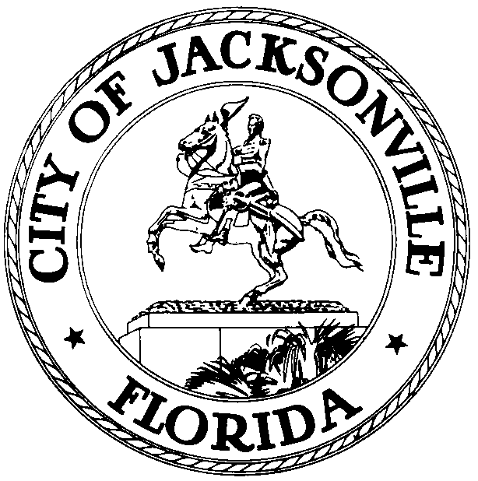

OFFICE OF THE CITY COUNCIL

CHERYL L. BROWN 117 WEST DUVAL STREET, SUITE 425
DIRECTOR 4TH FLOOR, CITY HALL
OFFICE (904) 630-1452 JACKSONVILLE, FLORIDA 32202
FAX (904) 630-2906
E-MAIL: CLBROWN@coj.net
NOTICE - AMENDED

May 27, 2009
1:00 pm

Notice is hereby given that the Jacksonville City Council will meet on Wednesday, June 24, 2009, 12:00 p.m., Council Chamber- 117 West Duval Street, 1st Floor City Hall St. James Building, Jacksonville, Florida. The ceremony is held to install the Honorable Richard Clark as the 2009-2010 Council President and the Honorable Jack Webb as the 2009-2010 Council Vice President. In accordance with Council Rules the positions will become effective July 1, 2009. (Invited attendees will include the Jacksonville City Council Members, Constitutional officers, Judges, Duval Delegation, and Congressional Representatives, appointed Board and Commission members of the City of Jacksonville as well as the public at large.) Invitations are not required to attend this event.

All interested parties are invited to attend. Please contact the Legislative Services Division at 630-1404 for additional information.

RC/Clb/clb

XC: Council Members 2007-2011
Cityc@coj.net
Cheryl Brown, Director/Council Secretary
Dana Farris, Chief, Legislative Services Division
Carol Owens, Assistant Chief Legislative Services Division
Jeff Clements, Chief, Research Division
Kristi Sikes, Chief, Administrative Services Division
Steve Rohan, OGC
Peggy Sidman, OGC
Alan Mosley, CAO, Mayor’s Office
Adam Hollingsworth, Mayor’s Office
City Council Calendar
Electronic Posting – 1st Floor City Hall
Web Posting
Media

Approved: 5.27.09 – 10:15 am -RC

