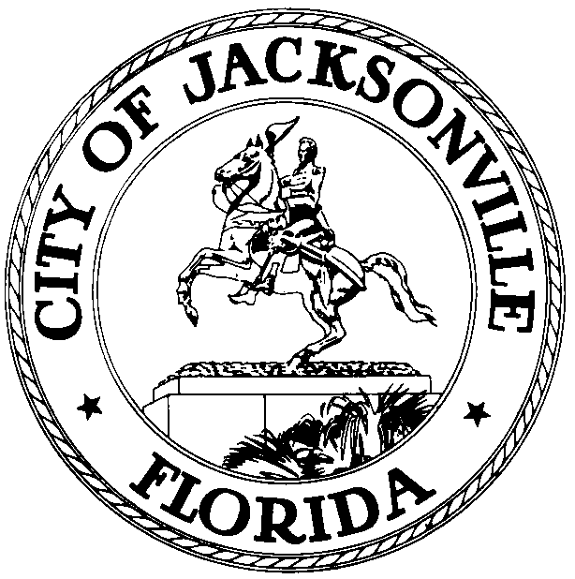

OFFICE OF THE CITY COUNCIL

KEVIN E. HYDE  COUNCIL MEMBER  AT-LARGE, GROUP FOUR  OFFICE (904) 630-1398  FAX (904) 630-2906 |  | SUITE 425, CITY HALL  117 WEST DUVAL STREET  JACKSONVILLE, FLORIDA 32202  E-MAIL: KHYDE@coj.net

April 23, 2009
12:30 p.m.

NOTICE

Notice is hereby given that Council Member Kevin Hyde will meet with Council Member Art Graham and the members of the Beaches Trolley Task Force at 5 p.m. on Monday, May 4, 2009 to discuss the Summer 2009 Cooperative Beaches Trolley Project. The meeting will be held at the Jacksonville Beach Community Center, Small Conference Room, 2508 South Beach Parkway in Jacksonville Beach, Florida.

All interested persons are invited to attend.

Please contact Alison Miller, Assistant to Kevin Hyde, Council Member At-Large, Group 4, at (904) 630-1398 for additional information or correspondence.

KEH/aem

cc: Council Members/Staff
Cheryl L Brown, Director/Council Secretary
Dana Farris, Chief –Legislative Services
Carol Owens, Assistant Chief – Legislative Services
Jeff Clements, Chief of Research
CITYC@COJ.NET
Office of General Counsel
Electronic Notice Kiosk – 1st Floor City Hall
Public Notice System – City Council Web Page
Media Box
File Copy

