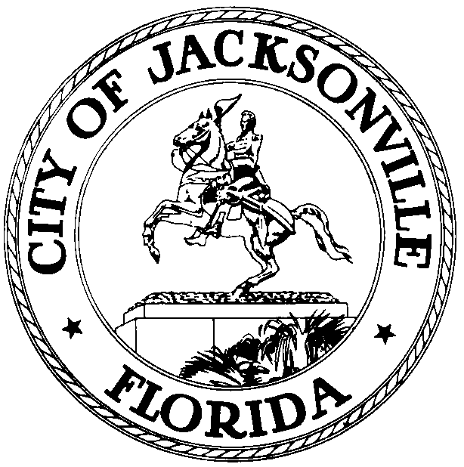
OFFICE OF THE CITY COUNCIL
JOHN D. “JACK” WEBB  COUNCIL MEMBER, DISTRICT 6  OFFICE (904) 630-1388  FAX (904) 630-2906  E-MAIL: webb@coj.net |  | 117 West Duval Street  SUITE 425  JACKSONVILLE, FLORIDA  32202

CANCELLED
April 20, 2009
11:00 a.m.

Meeting Notice

Notice is hereby given that the meeting with Council Member Jack, Council Member Stephen Joost and Council Auditors Kirk Sherman, Kyle Billy and Robert Campbell on Monday, April 20, 2009 at 1:00 p.m., in Conference Room B, located at 117 West Duval Street, Suite 425, City Hall St. James Building, to discuss the Council Auditors recommendations for Trail Ridge is cancelled.

All interested persons are invited to attend.

Please contact Suzie Loving, ECA-District 6, at (904) 630-1388, for additional information or correspondence.

cc: Council Members/Staff
Cheryl Brown, Director
Dana Farris, Chief, Legislative Services Division
Carol Owns, Assistant Chief of Legislative Services
Jeff Clements, Chief of Research
Office of the General Counsel
CityC@coj.net
Posted Notice Board – 1st Floor City Hall
Posted Meeting – City Council Calendar
Electronic Notification – 1st Floor City Hall
Posting to Public Notices – City Council Web Page

Media Box
File Copy

