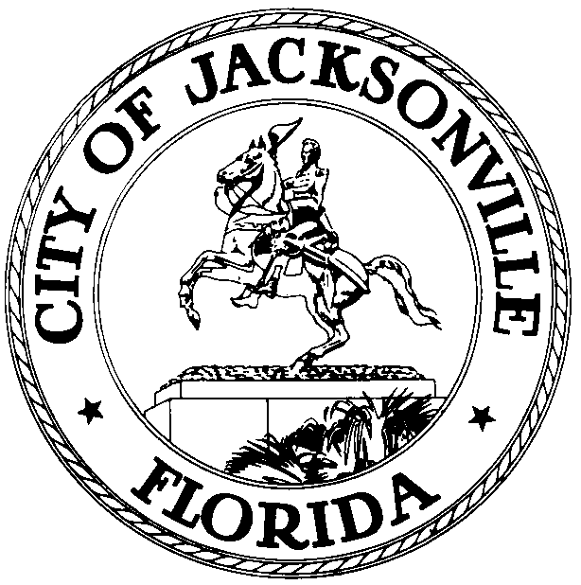

OFFICE OF THE CITY COUNCIL

GLORIOUS J. JOHNSON 117 WEST DUVAL STREET
COUNCIL WOMAN, AT-LARGE 5 SUITE 425
OFFICE (904) 630-1387 JACKSONVILLE, FLORIDA
FAX (904) 630-2906 32202
E-MAIL: gloriousj@coj.net

April 13, 2009
11:00 A.M.

M E E T I N G N O T I C E

Notice is hereby given that Council Member Glorious Johnson and Council Members Reggie Brown (Dist.10), Clay Yarborough (Dist.1) and Peggy Sidman, OGC representative of the Office of General Council, and Wayne Clark, Jacksonville Sheriff Office representative will meet on Tuesday, April 14, 2009 at 3:30 p.m. The meeting will take place in Conference Room B, Suite 425, 4th Floor at the St. James Building, located at 117 W. Duval Street, Jacksonville, Florida 32202 for the purpose of discussing, 2005-629 (Enacted 5/24/05) to resolved sexual predators placement issues.

All interested parties are invited to attend.

Please contact Sandra Lane, Executive Council Assistant, to Council Member Glorious Johnson, At-Large, Group 5, at (904) 630-1377, for additional information or correspondence.

CC: Council Members/Staff
Cheryl L Brown, Director
Dana Farris, Chief of Legislative Services
Carol Owens, Assistant Chief of Legislative Services
Jeff Clements, Chief of Research
Office of General Counsel
CityC@coj.net
Posted Notice Board – 1st Floor City Hall
Posted Meeting – City Council Calendar
Electronic Notification – 1st Floor City Hall
Posting to Public Notices – City Council Web Page
Media Box
File Copy

