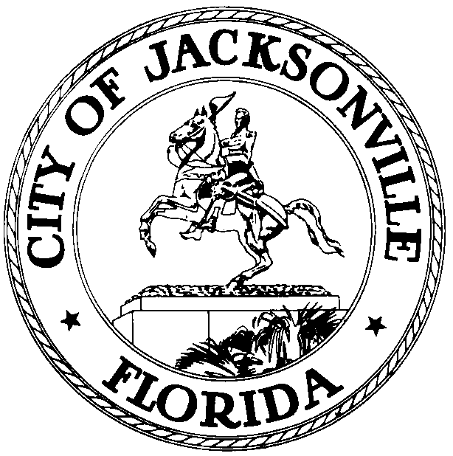
OFFICE OF THE CITY COUNCIL
JOHN D. “JACK” WEBB  COUNCIL MEMBER, DISTRICT 6  OFFICE (904) 630-1388  FAX (904) 630-2906  E-MAIL: webb@coj.net |  | 117 West Duval Street  SUITE 425  JACKSONVILLE, FLORIDA  32202

January 16, 2009
1:10 p.m.

Meeting Notice

Notice is hereby given that Council Member Jack Webb will meet with Councilman Stephen Joost on Tuesday, January 20, 2009 at 1:30 p.m. or at the conclusion of the Finance Agenda meeting in Conference Room B, located at 117 West Duval Street, Suite 425, City Hall St. James Building, to discuss International visits.

All interested persons are invited to attend.

Please contact Suzie Loving, ECA-District 6, at (904) 630-1388, for additional information or correspondence.

JDW/sml

cc: Council Members/Staff
Cheryl Brown, Director
Dana Farris, Chief, Legislative Services Division
Carol Owns, Assistant Chief of Legislative Services
Jeff Clements, Chief of Research
Office of the General Counsel
CityC@coj.net
Posted Notice Board – 1st Floor City Hall
Posted Meeting – City Council Calendar
Electronic Notification – 1st Floor City Hall
Posting to Public Notices – City Council Web Page

Media Box
File Copy

