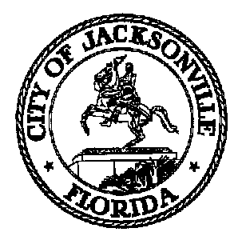

Michael Corrigan Jacksonville City Council
Council District 14 Suite 425, City Hall
Office (904) 630-1390 117 W. Duval St., Jax, FL. 32202

September 21, 2009
(3:30 p.m.)

AMENDED NOTICE
MEMORANDUM

FR: Michael Corrigan, Chair

TO: Warren A. Jones, Vice Chair
Reginald Brown, Member
Kevin Hyde, Member
Stephen Joost, Member

Subject Matter Experts:
Henry Cook, Jacksonville Retirement system Trustee
John Keane, Police and Fire Pension Administrator
Alan Mosley, Chief Administrative Officer- COJ
Shelia Sharp-Caulkins, Retired Employees Association President
David Kilcrease, JSO Corrections Officers Pension Advisory Committee

RE: Revised Committee Schedule for the Special Committee on City Pension Sustainability

Starting in the month of October, 2009, the Special Committee on City Pension Sustainability will meet once per month on the 3rd Tuesday of each month. As Chair of the Special Committee on City Pension Sustainability, I have scheduled a series of meetings to be held in the Council Chambers, at 117 W. Duval St., 1st Floor, City Hall St. James Bldg., at 3:00 P.M. on the following dates:

October 20, 2009
November 17, 2009
December (no meeting due to Council Break)
January 20, 2010 (Wednesday due to MLK Holiday)
February 17, 2010 (Wednesday due to Presidents’ Day Holiday)
March 16, 2010
April 20, 2010
May 18, 2010

Please mark your calendar accordingly.

If you have questions, please call Sharonda Davis, Legislative Assistant II at (904) 630-1404.

Thank you.

cc: Council Members/Staff
Cheryl Brown, Director- Jacksonville City Council
Dana Farris, Chief, Legislative Services Division
Carol Owens, Assistant Chief of Legislative Services
Jeff Clements, Chief of Research
Kirk Sherman, Council Auditor
Thomas Carter, Assistant Council Auditor
Margaret Sidman, Office of General Counsel
Derrel Chatmon, Office of General Counsel
Sherry Hall, Office of Mayor
File

