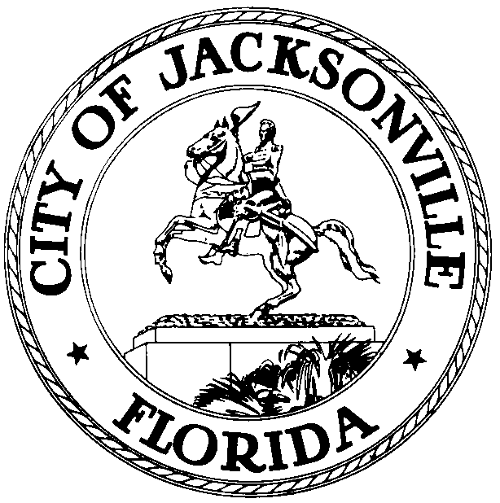

OFFICE OF THE CITY COUNCIL

KIRK SHERMAN 117 WEST DUVAL STREET, SUITE 200
COUNCIL AUDITOR 2nd FLOOR, CITY HALL
OFFICE (904) 630-1652 JACKSONVILLE, FLORIDA 32202

November 14, 2008
(6:40 AM)

NOTICE

Notice is hereby given Sherman, Council Auditor, will meet with the Honorable Ronnie Fussell, Honorable Michael Corrigan, Honorable Richard Clark, Alan Mosley, CAO- Office of the Mayor and members of the Miami-Dade County Commission, on Monday, November 17, 2008, at 12:00 pm in Conference Room A, located at 117 West Duval Street, Suite 425, City Hall St. James Building. The meeting is to discuss the Council Auditor’s role, function, and structure in the Consolidated City of Jacksonville. Members of the Miami-Dade Commission will visit the Council Chambers and view the Standing Committee Process.

All interested persons are invited to attend.

Please contact Janice Billy, Assistant Council Auditor, at (904) 630-1625 for additional information or correspondence.

CLB/clb

xc: Council Members/Staff
Alan Mosley, CAO, Office of the Mayor
Cheryl L Brown, Director/Council Secretary
Dana Farris, Chief –Legislative Services
Carol Owens, Assistant Chief – Legislative Services
Jeff Clements, Chief of Research
CITYC@COJ.NET
Office of General Counsel
Electronic Notice Kiosk – 1st Floor City Hall
Public Notice System – City Council Web Page
Media Box
File Copy

