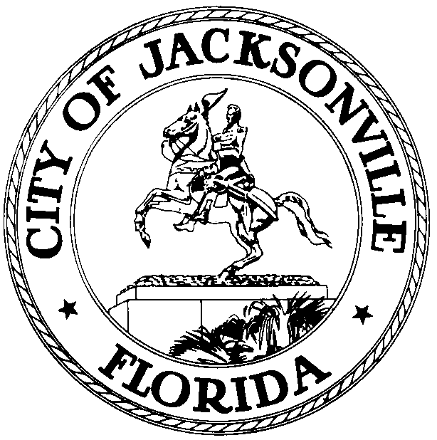

OFFICE OF THE CITY COUNCIL

RONNIE FUSSELL 117 WEST DUVAL STREET, SUITE 425
2008 – 2009 PRESIDENT 4TH FLOOR, CITY HALL
OFFICE (904) 630-1393 JACKSONVILLE, FLORIDA 32202
FAX (904) 630-2906
E-MAIL: RONNIEF@COJ..NET

October 6, 2008
(4:50 p.m.)

NOTICE

M E M O R A N D U M

TO: Council Members
Council Staff

FR: The Honorable Ronnie Fussell, President
Jacksonville City Council

RE: Date Change for November 11, 2008 City Council Agenda and Council Meeting
_____________________________________________________________

Notice is hereby given that The Honorable Ronnie Fussell, President, Jacksonville City Council, is hereby changing the Council Agenda Meeting and Standing Council Meeting from Tuesday, November 11, 2008 to Monday, November 10, 2008. The Agenda Meeting will be held at 3:00 p.m. in the Lynwood Roberts Room, 1st Floor -117 West Duval Street, City Hall St. James Bldg. The Council Meeting will take place at its regularly scheduled time of 5:00 p.m. in Council Chambers, 1st Floor, 117 West Duval Street, City Hall St James Bldg. Please note that change is due to an Official Holiday and all City Offices will be closed.
Please mark your calendars accordingly. All interested parties are invited to attend.
If you have any questions, please contact the Legislative Services Division at (904)630-1404.

RF/clb

xc: Council Members/Staff
Cheryl L. Brown, Director/Council Secretary
Dana Farris, Chief – Legislative Services Division
Carol Owens, Assistant Chief – Legislative Services Division
Jeff Clements, Chief, Research Division
Planning and Development Department
Kristi Sikes, Chief, Administrative Services Division
Mayor’s Office
Office of the General Counsel
CITYC@COJ.NET
Electronic Notice Kiosk – 1st Floor City Hall
Public Notice System – City Council Web Page
Media Box
File Copy

