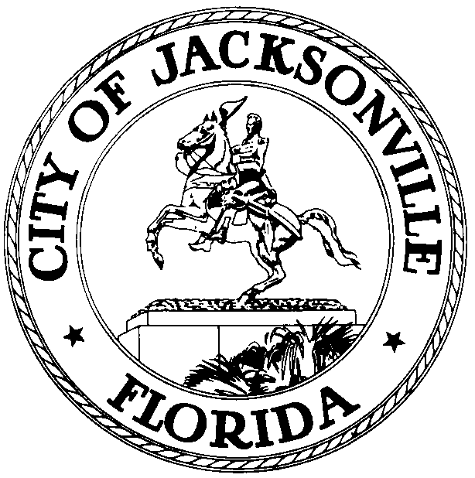
OFFICE OF THE CITY COUNCIL
WILLIAM BISHOP, AIA  COUNCIL MEMBER, DISTRICT 2  OFFICE (904) 630-1392  FAX (904) 630-2906  E-MAIL: wbishop@coj.net |  | 117 West Duval Street  SUITE 425  JACKSONVILLE, FLORIDA  32202
July 16, 2008

2:15 p.m.

Meeting Notice

Notice is hereby given that Council Member Bill Bishop, Chair, Jacksonville Waterways Commission, will meet with Waterways Commissioner Steve Nichols and Waterways Coordinator/Dockmaster Jim Suber, on Thursday, August 7, 2008, at 1:00 p.m., in Conference Room A, City Council Offices, 117 West Duval Street, Suite 425, City Hall at St. James Bldg., to discuss possible review of Jacksonville's boating ordinance.

All interested parties are encouraged to attend.

Please contact Suzanne Warren, ECA, District 2, for additional information at 630-1392.

WB/sgw

cc: Council Members & Staff
Cheryl Brown, Director/Council Secretary
Dana Farris, Chief, Legislative Services Division
Jeff Clements, Chief, Research Division
Office of the General Counsel
Cityc@coj.net
Posted Meeting - City Council Calendar
Electronic Notification - 1st Floor City Hall
Posting to Public Notices - City Council Web Page
City Council kiosk
Media Box

