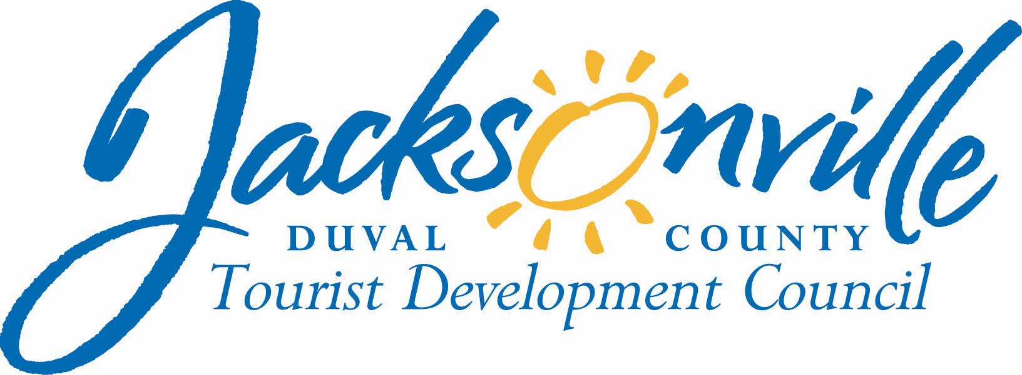
NOTICE
April 4, 2008

TO: Jim Ewing, TDC Subcommittee Member
Henry Fonde, TDC Subcommittee Member

FROM: Fred Pozin
Chairman, TDC Subcommittee

REFERENCE: TDC Subcommittee on Multiple City Events

A meeting of the Tourist Development Council (TDC) Subcommittee on Multiple City Events is scheduled for Thursday, April 24, 2008, at 10 a.m. The meeting will be held at City Hall at the St. James Building, 117 W. Duval Street, Conference Room B, Fourth Floor, Suite 425. The purpose of the meeting is to discuss and study multiple city weekend events.

All interested parties are welcome to attend.

Please contact Annette Hastings, TDC Executive Director (630-7625), if you cannot attend.

cc: Cheryl Brown, Director/Council Secretary
Janice Billy, Assistant Council Auditor
Jim McCain, Assistant General Counsel
John Reyes, CVB President
Vicky Koele-Bryan, JH&MA Administrator
CityC-E-mail
Media
Electronic Posting – 1st Floor City Hall
Web Posting

Annette R. Hastings
TDC Executive Director
117 West Duval Street, Suite 425
Jacksonville Fl, 32202
(904)630-7625
ANNETTEH@COJ.NET

