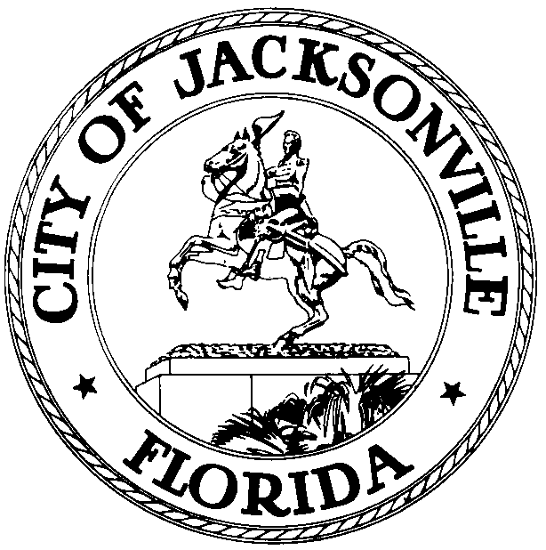

NOTICE

July 5, 2007

An Executive Council Assistant’s “Orientation and Training Workshop” has been scheduled for Thursday, July 12, from 8:00 am to 12:00 pm, in Conference Room “A”, 117 West Duval Street, Suite 425. Staff from the Office of Council Director, Office of General Counsel and the City Ethics Office will conduct Orientation and Training on the following Issues: Office Structure, Human Resources Documentation, Posting to the City Council Calendar and Reserving Meeting Rooms, ECA Noticing Requirements, Documentation, and Posting, Sunshine Law and Ethics.

Interested persons are invited to attend.

Please contact Cheryl L Brown, Director, with any questions, via e-mail at Clbrown@COJ.NET
or by telephone at 630-1452.

xc: Council Members & Staff

Council Auditors
Peggy Sidman, OGC
Steve Rohan
CouncilRecords@COJ.NET
Posting 1st Floor – City Hall
Web Posting- City Council
CITYC, E-mail group
Media

